Django Templates

Django provides a convenient way to generate dynamic HTML pages by using its template system.

A template consists of static parts of the desired HTML output as well as some special syntax describing how dynamic content will be inserted.

Why Django Template?

In HTML file, we can't write python code because the code is only interpreted by python interpreter not the browser. We know that HTML is a static markup language, while Python is a dynamic programming language.

Django template engine is used to separate the design from the python code and allows us to build dynamic web pages.

28.5M

661

OOPs Concepts in Java

Django Template Configuration

To configure the template system, we have to provide some entries in **settings.py** file.

1. TEMPLATES = [
2. {
3. 'BACKEND': 'django.template.backends.django.DjangoTemplates',
4. 'DIRS': [os.path.join(BASE_DIR,'templates')],
5. 'APP_DIRS': True,
6. 'OPTIONS': {
7. 'context_processors': [
8. 'django.template.context_processors.debug',
9. 'django.template.context_processors.request',
10. 'django.contrib.auth.context_processors.auth',
11. 'django.contrib.messages.context_processors.messages',
12. ],
13. },
14. },
15. ]

Here, we mentioned that our template directory name is **templates**. By default, DjangoTemplates looks for a **templates** subdirectory in each of the INSTALLED_APPS.

Django Template Simple Example

First, create a directory **templates** inside the project app as we did below.

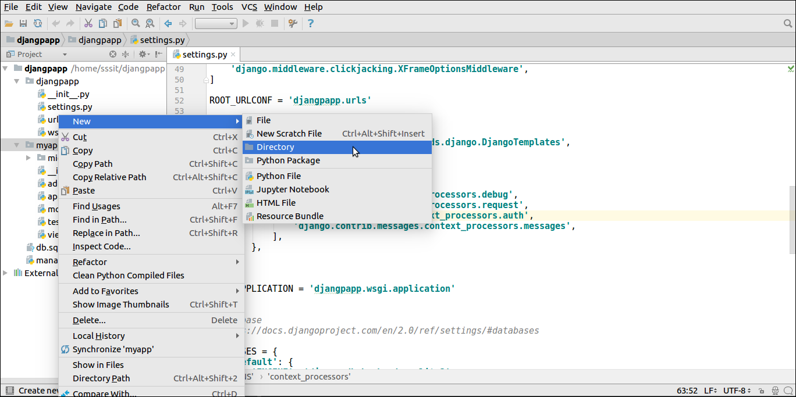

After that create a template **index.html** inside the created folder.

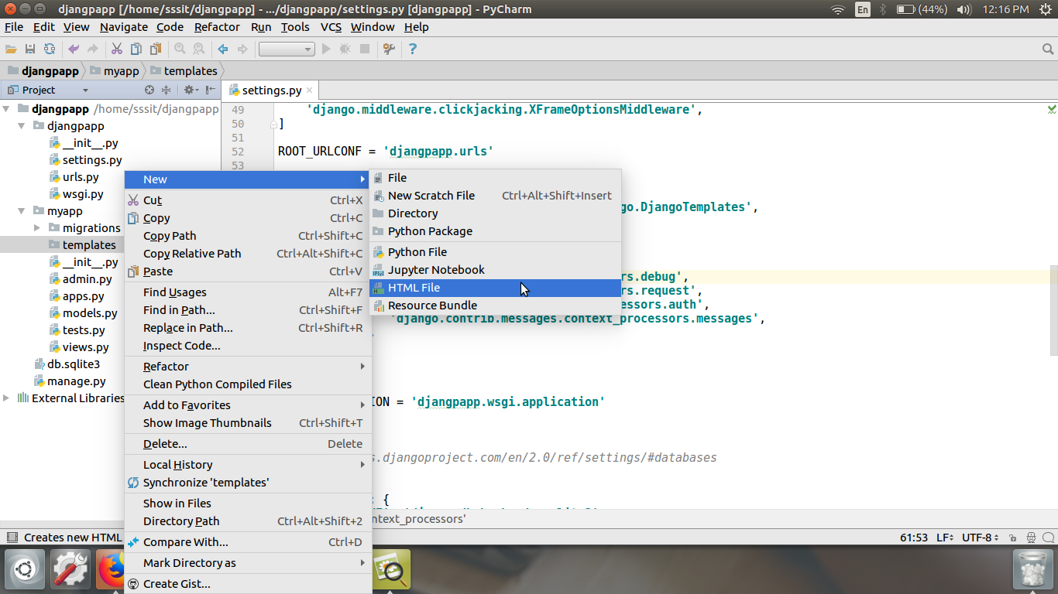

Our template **index.html** contains the following code.

**// index.html**

1. <!DOCTYPE html>
2. <html lang="en">
3. <head>
4. <meta charset="UTF-8">
5. <title>Index</title>
6. </head>
7. <body>
8. <h2>Welcome to Django!!!</h2>
9. </body>
10. </html>

Loading Template

To load the template, call get_template() method as we did below and pass template name.

**//views.py**

1. from django.shortcuts **import** render
2. #importing loading from django template
3. from django.template **import** loader
4. # Create your views here.
5. from django.http **import** HttpResponse
6. def index(request):
7. template = loader.get_template('index.html') # getting our template
8. **return** HttpResponse(template.render())       # rendering the template in HttpResponse

Set a URL to access the template from the browser.

**//urls.py**

1. path('index/', views.index),

Register app inside the INSTALLED_APPS

1. INSTALLED_APPS = [
2. 'django.contrib.admin',
3. 'django.contrib.auth',
4. 'django.contrib.contenttypes',
5. 'django.contrib.sessions',
6. 'django.contrib.messages',
7. 'django.contrib.staticfiles',
8. 'myapp'
9. ]